It is the Artist’s sole responsibility to ensure that their 2D artwork is framed correctly and ready for secure hanging at the TRAG Gallery & Gifts

Select a Frame
Consider creating work that will fit in standard-sized mats and frames.
- Showcase your artwork and not the frame! Simple mats and frames are just fine!
- Canvases must be framed, or gallery wrapped.

2. Choose correct hardware for the back of your work
Please use good D-rings, larger screw eyes, metal-frame D-rings, all securely installed.
Examples of Acceptable Hooks:
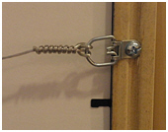 | 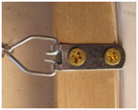 |  | 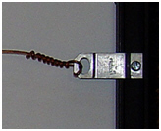

Please, no clip-frames, saw-tooth hangers, a single triangle hanger at the center, back of frame, triangle hangers/wires that are not attached to the sides of frames, very small screw eyes or corded backs Examples of Unacceptable Hooks:
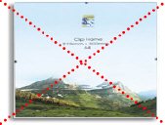  Clip Frame | 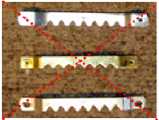  Saw-Tooth Hangers | 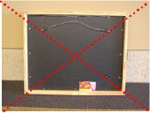  Wire Not Attached to Frame | 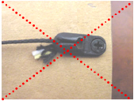  Hanger Not Attached to Frame

3. Hanging Wire

- For the safety of your artwork, please use quality picture hanging wire.
- Please refrain from using fishing line, electric wire and mesh cord.
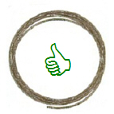  Quality Picture Hanging Wire | 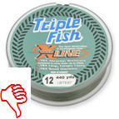  No Fishing Line | 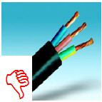  No Electrical Wire | 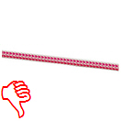  No Corded Wire

4. Attaching Hardware and Hanging Wire to the backs of Frames

- When adjusting your hanging wire, make sure to leave plenty of lead to wrap around the wire after looping your D-Ring or screw eye—it is more secure that way.
- We recommend looping your D-Ring hardware twice for increased safety of your artwork.
- Tape all ends of wires so it does not cut the 2D displayer.

- Please make sure that your D-rings are attached correctly on your frame. Best practice is to have the D-rings attached 1/3 of the way down your frame.
- Your hanging wire should be long enough so that, when pulled up tight, the top of the wire is about 2” from the top of the frame.
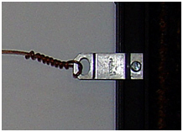  Lead wire securely wound around D-Ring | 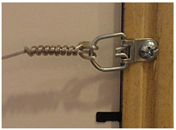  Double Loop through D=Ring | 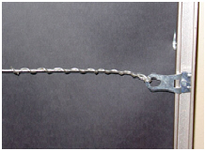  Secure lead through ring tightly wound
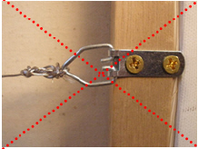  Short lead wire can come apart | 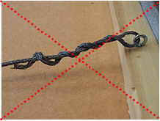  Loose wrap can unravel | 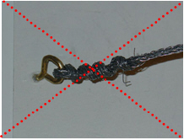  Short wire not cleanly wound and fraying
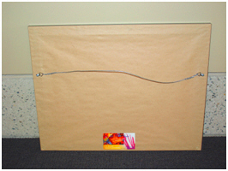

5. Labeling your work…even if you sign the front!
- Please attach a small card that displays your full contact information and the title of each work securely to the back of your artwork. You will also display the TRAG inventory tag with price.

Clean your artwork before your exhibit
- As this will be the first time that many customers are introduced to your work and to you as the artist. Make a good first impression!
- Dust off your work, remove fingerprints from the glass, clean out any dirt and repair any damage on the outside AND inside of your work.
- Make sure any mats are pressed snugly to the glass or Plexiglas and are not crooked in the frame, “bubbling” out or loose in the frame.

